
Update your SMS and Voicemail settings

If you have the iOS 26 update, you will need to update your settings to keep receiving updates from the library.
What you need to do

Save Our Number(s): Add the library’s phone number(s) to your contacts so you don’t miss important notifications and phone calls.
Our Number
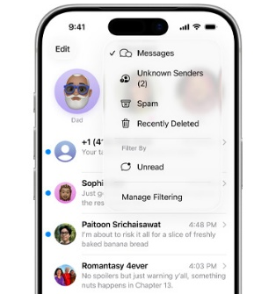
(123) 456-7890
Check Your “Unknown Senders” Tab: If you’re expecting a message and don’t see it, look here. Some texts may end up in your junk folder, too.

